[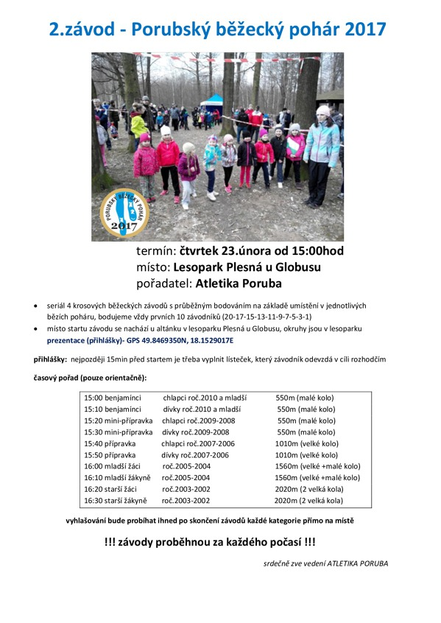](http://www.atletikaporuba.cz/imagebank/31164860/900/900/2.porubsk%C3%BD_b%C4%9B%C5%BEeck%C3%BD_poh%C3%A1r_2017_orig.jpg)